A few rules for a happy playgroup

* Nice if you try to participate at lunch time every day at 11.00. Children learn from each other, have a good time together and it`s social. We teach them to sit at the table when we eat, and no food where the toys are.
* Choose which activity you want to join in, take an active part in it together, include others and have fun☺
* The floors can be cold, so you can bring slippers. You also need to bring food, drink and other things your child need for the day.
* In the kindergarten we try to tidy up together with your child after a meal or after playtime. Good habits needs to work on☺
* We like an including environment where we talk nicely to each other, with an “Hello” or “Good bye”. And show respect and tolerance for our differences.
* Running and shouting is best to do outside at the playground.
* NOTE!

Remember to only take pictures of your own children, video camera is not allowed.

* And it`s not allowed to post online or distribute pictures of other children at Facebook, YouTube etc.
* Your Phone need to be in your pocket or bag at all time, the kindergarten is phone free environment for the children!!!

C:\Documents and Settings\sk15491\Mine dokumenter\Mine bilder\Microsoft Clip Organizer\j0438221.wmfYou child is gone be your focus, and you gone experience the good moments together☺



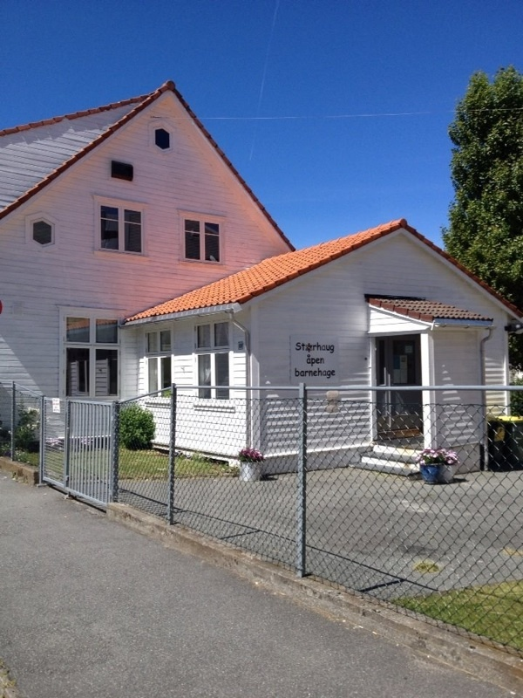

English

Monday:

09.30 The Kindergarten opens

10. 30 Circle time (0-5 years)

11.00 Lunch (Please, bring lunch. Coffee,

tea and fruit will be served.)

11.45 Free play (games, crafts, painting, outside play)

12.00 Junior club for children from ca 2, 5 years old

13.15 Time to tidy up and get dressed

13.30 The playgroup closes

Tuesday:

09.30 The Kindergarten opens

10.30 Christian circle time (0-5 years)

11.00 Lunch (Please, bring lunch. Coffee,

tea and fruit will be served.)

12.00 Song group for babies (0- 12 months)

13.15 Time to tidy up and get dressed

13.30 The playgroup closes

Wednesday:

09.30 The Kindergarten opens

10. 30 Circle time (0-5 years)

11.00 Lunch (Please, bring lunch. Coffee,

tea and fruit will be served.)

11.45 Free play (games, crafts, painting, outside play)

13.15 Time to tidy up and get dressed

13.30 The playgroup closes

Thursday:

09.30 The Kindergarten opens

10.30 Circle time (0-5 years)

11.00 Lunch (Please, bring lunch. Coffee,

tea and fruit will be served.)

11.45 Free play (games, crafts, painting, outside play)

12.00 Song group for babies (0- 12 months)

14.15 Time to tidy up and get dressed

14.30 The playgroup closes

**USEFULL INFORMATION**

The playgroup staff are Liv Heidi Leavy (Leader), Anette Johannessen (assistant), Kjersti Stråbø Aase (assistant), Agata (cleaner) and Linda Olsen (accountant).

Phone number 465 23 606

E - mail [storhaugopenbarnehage@outlook.com](mailto:storhaugopenbarnehage@outlook.com)

Home page [www.openbarnehage.dinstudio.se](http://www.openbarnehage.dinstudio.se)

**Facebook page** Storhaug åpen barnehage

Registration Children and adults sign in at our registration form each day. For two reasons.

1. The Kindergarten needs to know who is inside at all times
2. And in case of fire.

So it`s important to cross your self out when you leave.

Playgroup activities

* Junior club (2,5-6 years) every Monday, at 12.00.
* We hold a Christian circle time every Tuesday.
* Baby circle-time (0-12 months) on Tuesdays and Thursdays at 12.00.
* We have art and craft, traditional celebration, trips, cooking and more. So follow for more specific dates.