)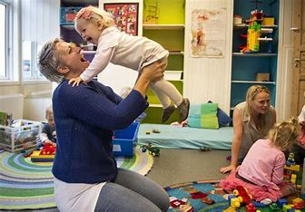  Stavanger aftenblad Published: 12 September 2013 "Storhaug is an example for the whole of Europe"  STORAHUG OPEN KINDERGARTEN  Central at Storhaug, behind Pedersgata. Our opening hours are Monday to Wednesday 9.30-13.30 Thursdays 9.30-14.30 If you want to participate in the circle time, you must be in the kindergarten until 10.30.  Baby singing for 0-12 months is at 12.00 on Tuesdays and Thursdays. We offer circletime and babysinging with Christian content on Tuesdays every week.  No sign-up  Free |  |  | 8 open kindergartens in different municipalities  Check the various kindergartens' online and on Facebook.  Storhaug Åpen barnehage har åpent Monday till Wednesday 9.30-13.30 og torsdag 9.30 -14.30. Closed Fridays  Hafrsfjord; Monday-Thursday 09.00-13.15  Smiodden: Tuesday-Thursday 9.30-13.45  Stokka; Wednesdays 9.00-15.00  IMI; Monday- Thursday 9.30-13.30,  Forus; Monday-Thursday 9.00-13.00  Bamsefaret; Monday and Thursday 9.00- 14.30 and Tuesdays 9.00-14.00  Veden; Monday-Thursday 9.00-13.00  We are cloesd in all school Holidays.  Storhaug Åpen barnehage  Nedre Dalgate 68  4013 Stavanger |  |  | Storhaug Åpen barnehage  - Open kindergartens in Stavanger municipality

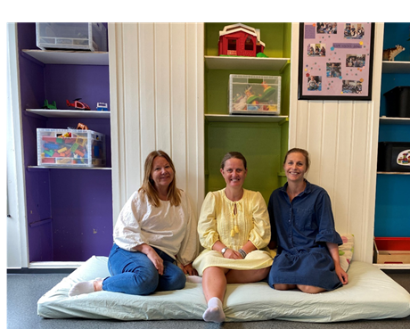  Liv Heidi, Anette and wish you all welcome to the Kindergarden  Children meet children |  |  | ROM  Exciting play environment on two floors. Pillow rooms, sensory rooms, role-play and dressing up. Construction play with the construction of various materials. Nice outdoor area, large selection of outdoor toys and bikes you can use during opening hours.  “We are focusing this year to develop the play environment in kindergarten."  CONTENT  Circletime with drums. Dramatization with music. Communal walks in the local community. Various crafting activities. Projects based on the team we have that month. Baby massages, yoga foods and music from other cultures are being planned.  STAFF  We are three regulars in the staff group One employee, Kjersti with over 10 years of experience as a nurse and one with 30 years in kindergarten, Anette, Liv Heidi is a board / educational leader with pre-school teacher education and long experience from kindergarten. |  |  |   Velkommen til oss  Open kindergarten is a place where all children from 0 to 6 years old are welcome along with a parent or childcare provider over the age of 18.  It costs nothing to come and you can come at any time during opening hours.  You must bring lunch if it is to be eaten in the kindergarten.  We have various events throughout the year such as Christmas party, UNday and summer closing.  Some open kindergartens are municipal while others are run by different churches. Storhaug open kindergarten is run by St Johannes parish.
Children get the opportunity to meet peers in play and exploration.
It is a social meeting place for parents.
Learning new songs and experiencing creative playrooms.
Multicultural community
Inclusive environment

Day routines:
9.30-we open
10.30 circle time
12.00 Baby singing/junior club/arts and crafts
13.30 closing time Monday- Wednesdays
14.30 Closing time Thursdays

